

CSE541 Computer Vision

Weekly Report

Section-1

Submitted to faculty: Prof. Mehul Raval

Date of Submission: 02 March 2022

Student Details

| Roll No. | Name of the Student | Name of the Program |
| --- | --- | --- |
| AU1940315 | Shubham Jain | BTech-CSE |
| AU1940169 | Gaurav Bajaj | BTech-CSE |
| AU1940215 | Raj Chauhan | BTech-CSE |
| AU1940118 | Raj Gariwala | BTech-CSE |

**Tasks Performed in the week:**

* Last time we studied the facenet inception model, how it works, and the layers used in the model. So now this week we studied and understood a pictorial representation of the model using the layers that we studied last week.
* We understood how these layers of max-pool, normalization, convolution and reshaping are interrelated to each other.
* We continued with further understanding of Deep Neural Networks and correlated it to what was taught in the lecture.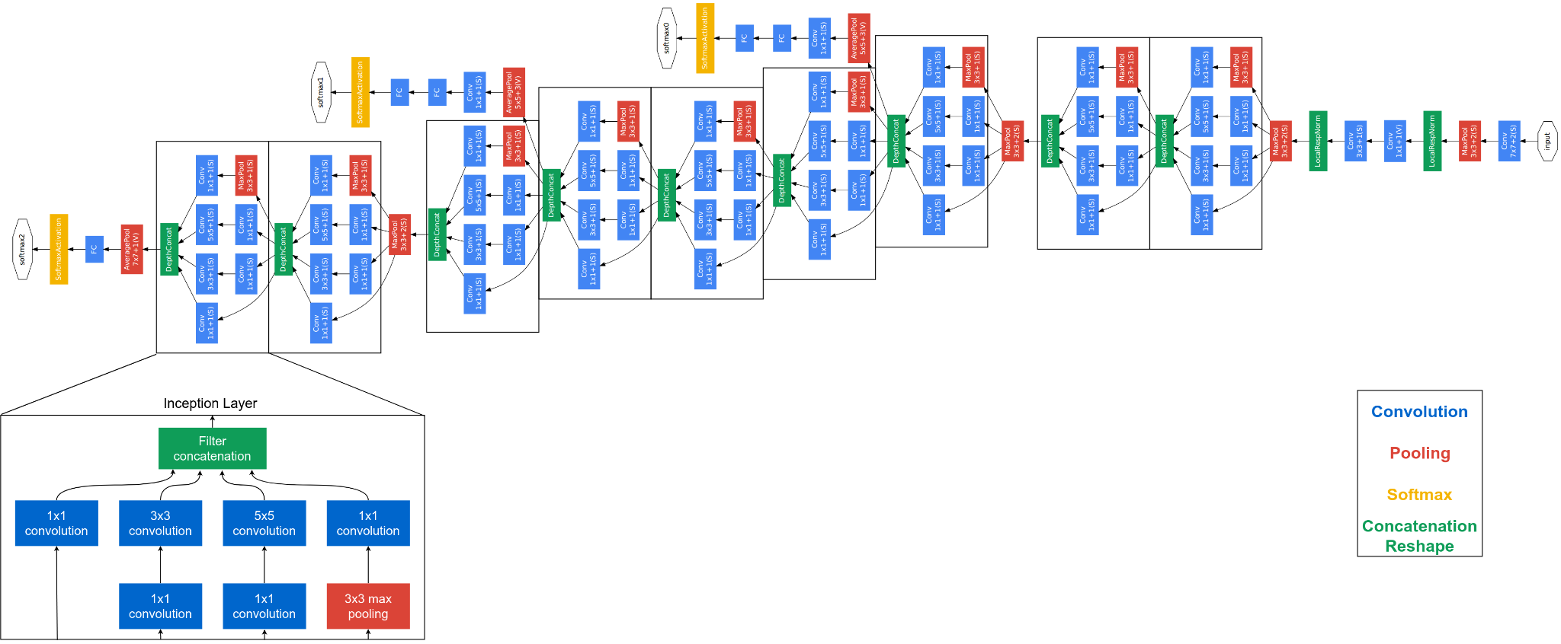

**Outcome of the tasks performed:**

* We were able to fairly understand the concepts of CNN inception model and point out the layers that are used in this model appropriately.
* We were also able to get a hold of Keras-OpenFace implementation for Facenet-based models.
* We were able to get a mathematical understanding of the concept behind Facent like L2 Euclidean space, etc.

**Tasks to be performed in the upcoming week:**

* We will further try to implement this model of FaceNet in python next week by using all the layers shown in the images.
* We will also try to construct our model for a project based on Facenet and its pre-trained model in Keras-OpenFace.